Neural Networks

Train a single Neuron Model:
To find the best edge weights using Dtrain data, Perception and Log reg are single neuron models for classification.
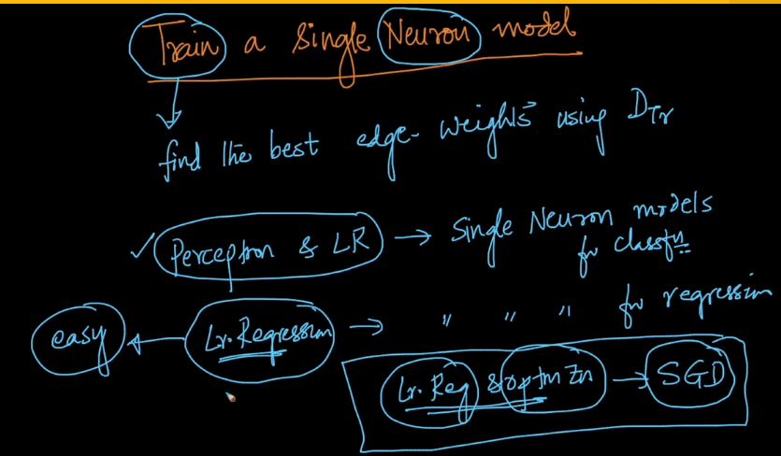
Linear regression problem: Linear regression and optimization. Here F is an identity function,F(x) = x
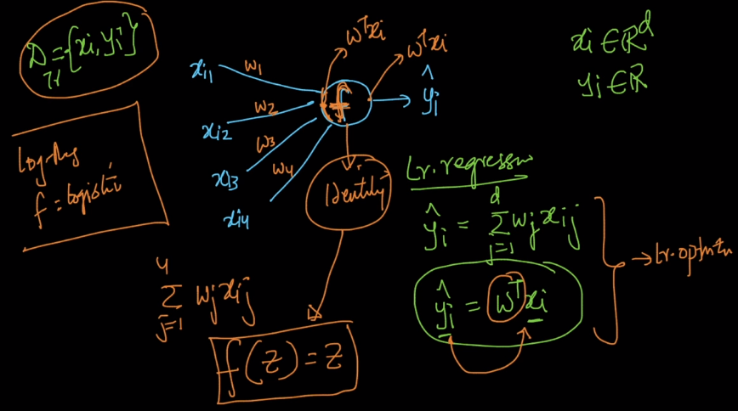
Logistic regression: But in case of logistic regression F is a logistic function.
The optimization problem for linear regression is as follows.

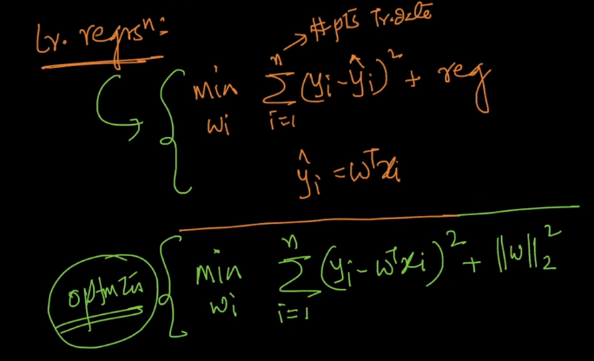
Neural networks in Depth -

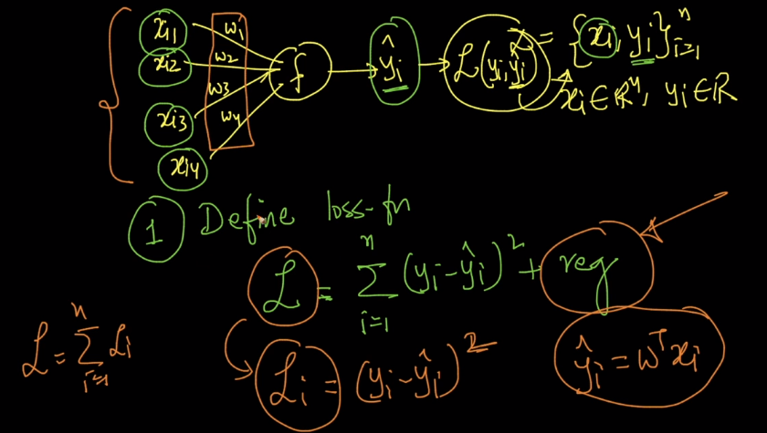

Optimization problem:
Find Wi that minimizes the optimization problem.
F is identity in case of Linear regression.
F is Threshold in case of perception.
F is Sigmoid in case of Logistic regression.
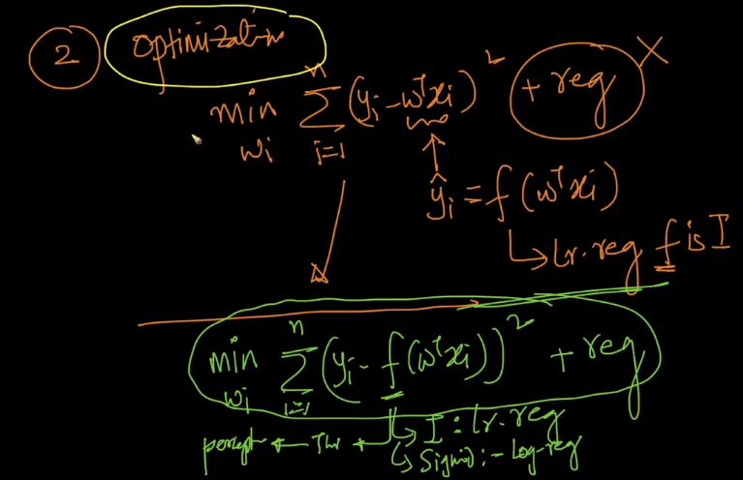
Solve the optimization problem:

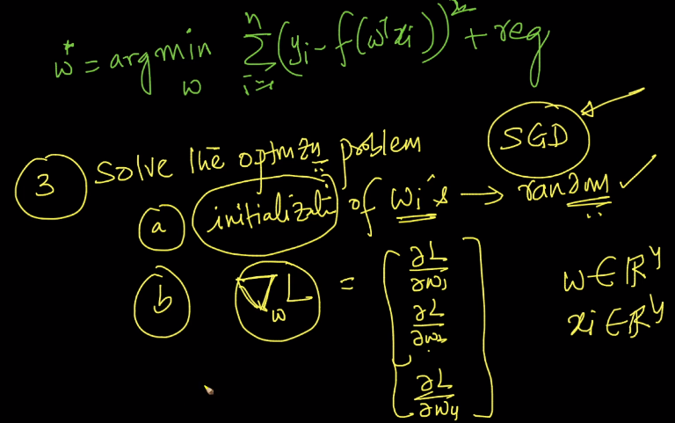
Updating weights -

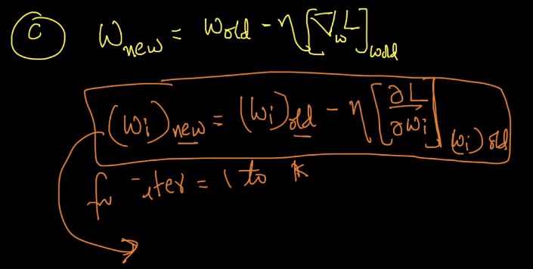
The key part is computing gradient descent we will use all the data for computing the new weights.
In SGD we will use the small batch of points and approximate the weight vector.

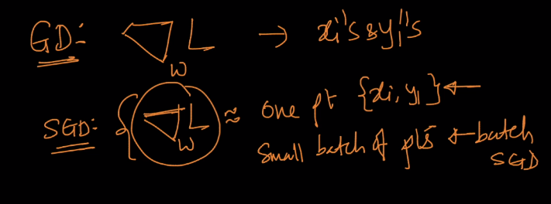

In regression we have squared loss for the network.

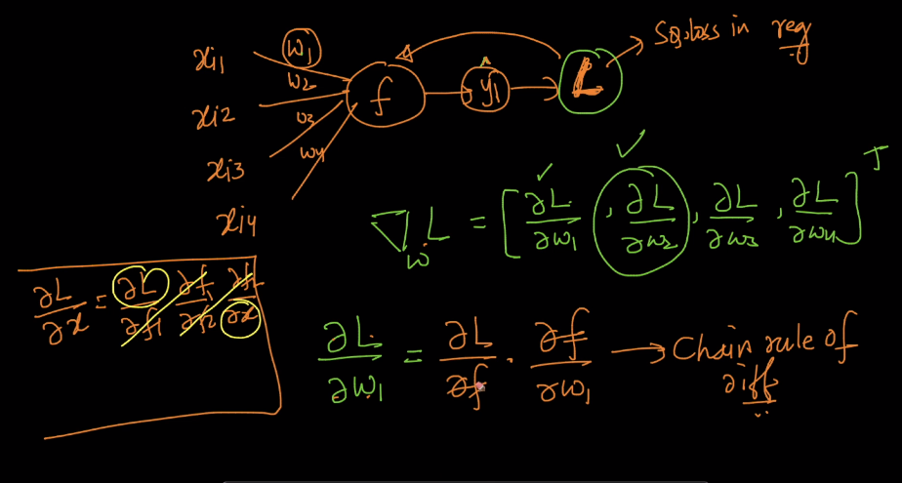
These are not ratios, they are derivatives :P.

Pictorial representation of derivatives:
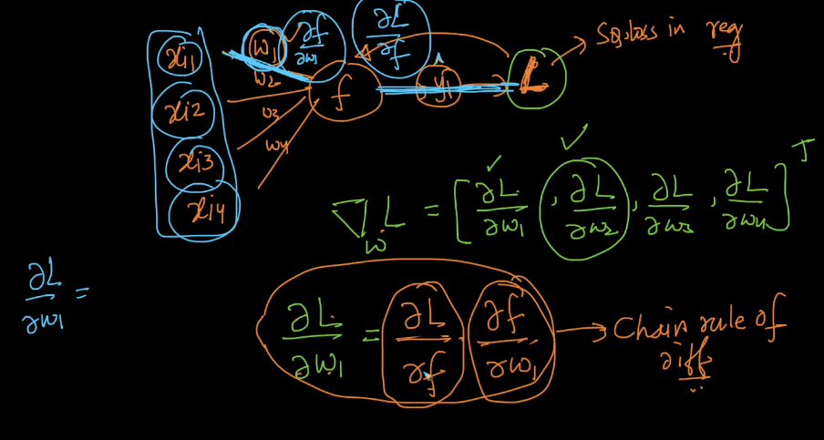

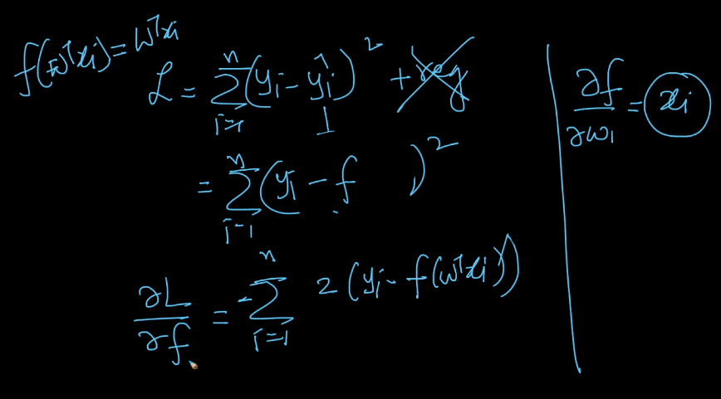
Training MLP : Chain Rule

